**23.Leap year or not.**

**Exercise**

* **Write a program to find whether a year entered by the user is a leap year or not.**

**Approach:**

**So here we did like this  
Check if the year is divisible by 400 or 4 but not 100, DISPLAY "is a leap year", Otherwise, DISPLAY ": is not a leap year.""**

**Solution 👇**

**Java :**

**import java.util.Scanner;**

**public class CodeXam {**

**public static void main(String[] args)**

**{**

**Scanner sc = new Scanner(System.in);**

**int year = sc.nextInt();**

**if ((year % 400 == 0) || ((year % 4 == 0) && (year % 100 != 0))) {**

**System.out.println(year + " : is a leap year");**

**}**

**else {System.out.println(year + " : is not a leap year.");**

**}**

**}**

**}**

**output:**

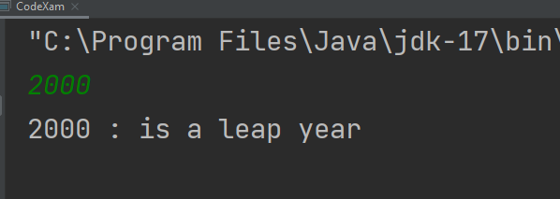

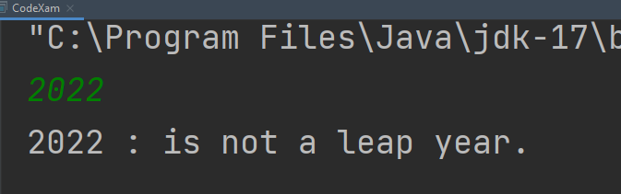

**Python :**

**year = int(input("Enter your Year:\n"))**

**leap_year = "It's a leap year !"**

**common_year = "It's not a leap year"**

**if year % 4 == 0:**

**if year % 100 != 0:**

**print(leap_year)**

**elif year % 400 == 0:**

**print(leap_year)**

**else:**

**print(common_year)**

**else:**

**print(common_year)**

**output:**

